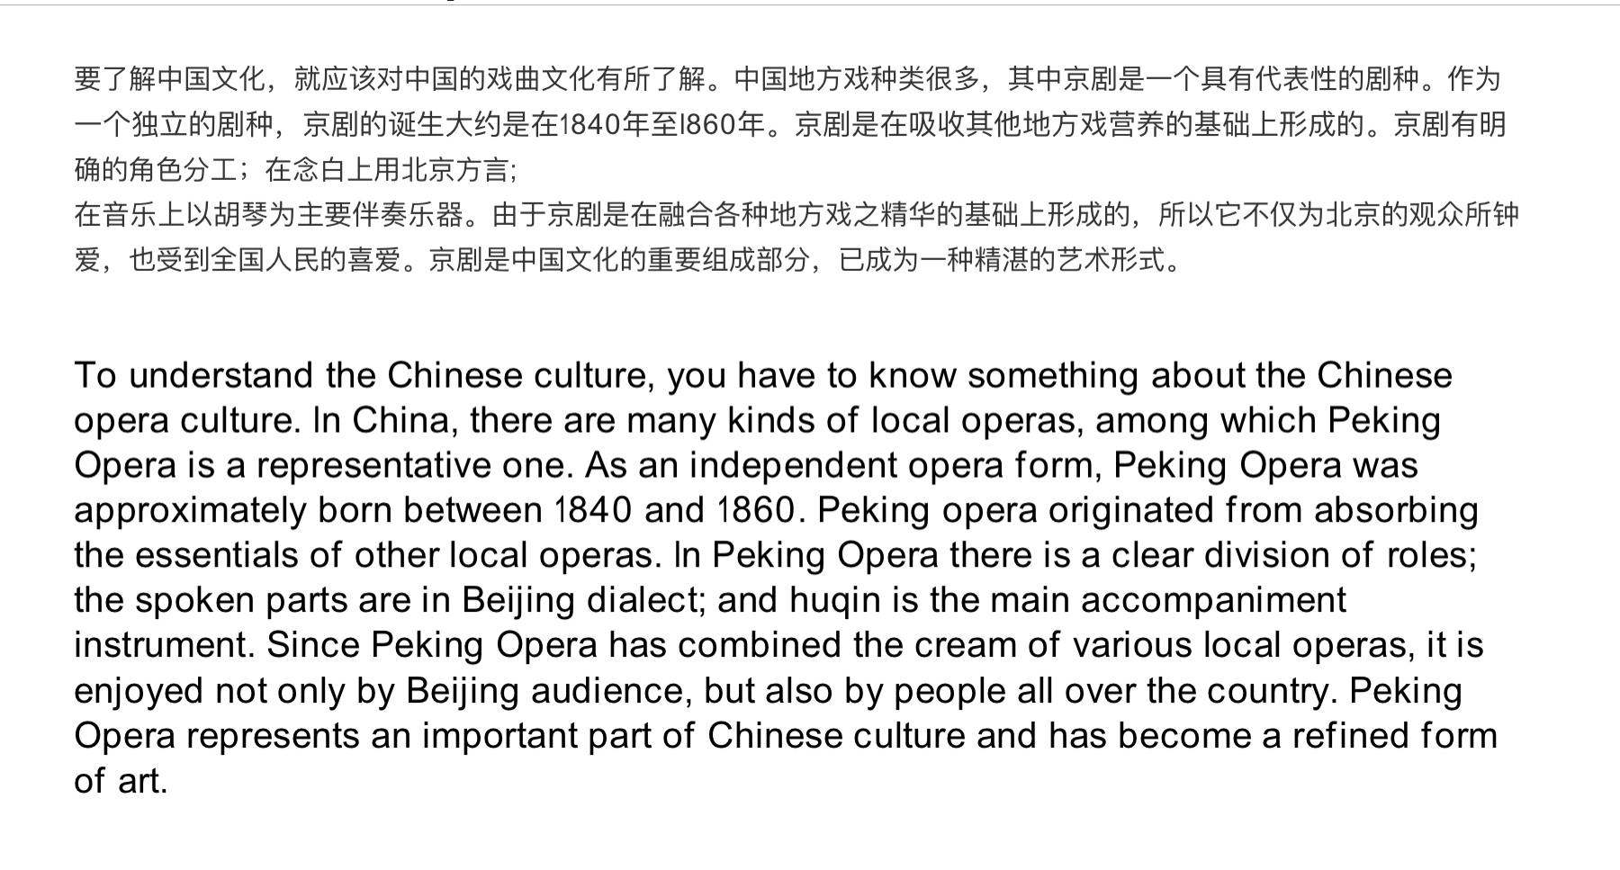It is necessary to know about Chinese traditional opera culture if you want to have an understanding of Chinese culture. There are a wide variety of Chinese local opera, within which the Beijing opera serves as a typical kind of opera. As a unique opera, Beijing opera originated between 1840 and 1860. It formed after taking in nutrition from other local operas, with clear role division. Its narrator tells the story using Beijing local language and uses Hu Qin as the main instrument to play the bgm. On grounds of the mixture of the core factor from all kinds of local operas, Beijing opera not only appeals to Beijing audience, it’s also favoured by people from all across the country. As a significant part of Chinese culture, Beijing opera has become a consummate form of art.

Teacher’s transition:

